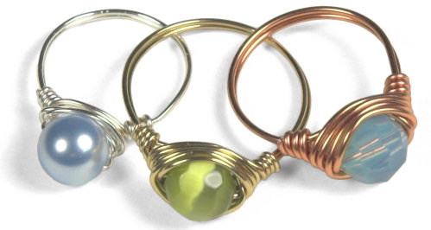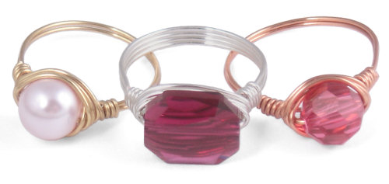

Simple Wire-Wrapped Ring Tutorial

This is about as "intro" as they come - a basic, simple wire wrapped ring with a single 8mm bead focal. For those of you just getting started with wire jewelry making, this is a terrific way to get your feet wet.
Parts Suggested: An 8mm Bead - Wire - 20 gauge or 22 gauge Tools - A wire cutter, chain nose pliers & a ring mandrel

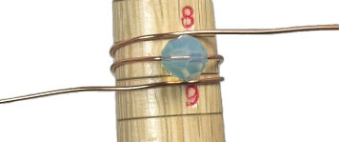 | Step 1  Cut a length of wire about 12" long. Put the 8mm bead in the middle of the wire, and lay it flat on the mandrel at the line indicating your chosen ring size. Wrap either end of wire around the mandrel and bring it back to the front so the wire ends lie to either side of the 8mm focal bead.
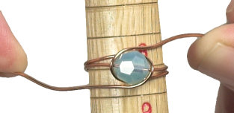 | Step 2  Firmly gripping the wire so it stays taunt, cross the wires around the bead.
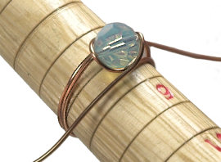 | Step 3  Again, keeping the wires taught, cross the wires again. As you cross the wires, you want the newly wrapped wire to lay underneath the previous crossed wire.
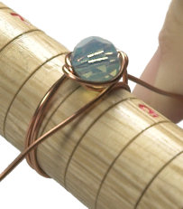 | Step 4  Keeping wrapping the wires around the circle of the bead, keeping pressure on the wire and making each new layer wrapped underneath the previous layer.
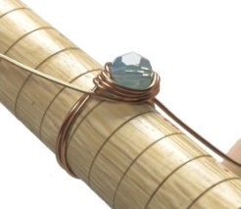 | Step 5  When you have either four or five wraps, then you're finished wrapping around the bead, take off the mandrel, it is time to finish the sides.
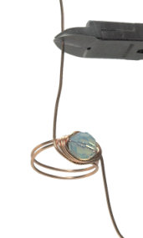 | Step 6  Before wrapping the sides, clip the excess wire - give yourself about 1.5" of wire on both sides to finish the ring.
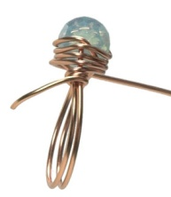 | Step 7  Wrap the tail of the wire around one side of the ring. Keep firm pressure on the wire to make nice, neat loops.
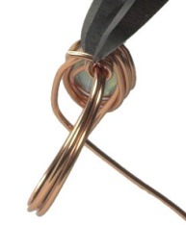 | Step 8  When you have three or four loops, snip off the excess wire with your wire cutters. I snip mine with the cut on top of the ring so that the end isn't underneath and poking my finger.
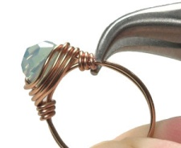 | Step 9  At this point, gently squeeze the newly cut tip of wire with pliers to snug it in so it won't catch or scratch.
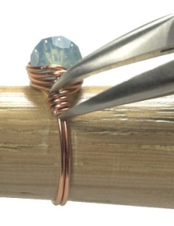 | Step 10  Now transfer the ring back to the ring mandrel. Your ring will not be perfectly shaped after you've finished the wrapping the sides. Now push it firmly down all the way. I turn it around in a circle a few times, and this brings the ring back to the nice, round shape it ought to have and straighten out any problems. If the side loops don't fit quite tightly together, you can gently manipulate them into place with pliers while the ring is snug on the mandrel.
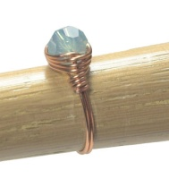 | Step 11  And that's it, folks! Ready to wear... (and ready to go make another one)
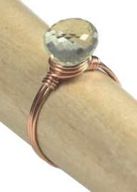 | Variation:  I used the same technique to make a sweet little ring out of an onion cut green amethyst stone. I had to use a skinnier wire (24 gauge) with this gem, so to make the ring a little stronger, I cut the wire a little longer, and crossed it around the back of the mandrel twice instead of once, for a four-strand wide band rather than a two-strand wide band.

http://www.lythastudios.com/123bead/project-46.html

